COLLEGE OF
I
E
S
ENGINEERING
CHITTILAPPILLY
Thrissur, Kerala – 680 551
PH: (91) 0487 2309966, 2309967
www.iesce.org
E-mail: mail@iesce.org

DEPARTMENT OF ELECTRONICS AND COMMUNICATION ENGINEERING

ECL 332 COMMUNICATION LAB
VI Semester B. Tech Electronics and Communication Engineering

(2019 SCHEME)


Name: Reg No: Sem: VI
Course Name: Communication Lab
Course Code: ECL 332

COLLEGE OF ENGINEERING CHITTILAPPILLY
I I

E
S
Thrissur, Kerala – 680 551


Name of the laboratory/ Workshop :
Name of the student :
Branch :……………………semester…………………
Roll No :…………………..Year……………………..
-------------------------------------------------------------------------------------------------------------------------------------
CERTIFICATE

Certified that this is the bonafide record of practical work done by……………………………………………in the ……………………………………..of this institution during the year 2024-2025

Staff –In-Charge

Date:…………………… Dept. Seal

Head of the Department

Submitted for the practical exam held on ……………………………………..with university register number………………………………..

Internal Examiner External Examiner
Date:………………..
Place:………………..

DEPARTMENT OF ELECTRONICS AND COMMUNICATION ENGINEERING

.

Vision of the Department
To impart excellent technical education in the field of Electronics and Communication Engineering to produce competent professionals with social commitment.

Mission of the Department
M1: To provide in-depth knowledge of principles and applications related to design and development of technology for societal needs.
M2: To initiate innovations by connecting core knowledge with multidisciplinary domains.
M3: To provide state of the art technical education in Electronics & Communication Engineering at UG and PG levels.
M4: To encourage faculty members for professional up gradation.

PROGRAM EDUCATIONAL OBJECTIVES (PEOS)

PEO1: To attain strong theoretical and practical knowledge in Electronics and Communication Engineering, enabling graduates to become competent project leaders and successful organizational leaders in industry and research.
PEO2: Develop design capability to create and improve technical products
PEO3: Be receptive to new ideas and technology and attain professional competence through continuous learning

Program Specific Outcomes (PSOs)
PSO1: Apply the basics and fundamental concepts of Electronics & Communication Engineering to design and realize various components and systems for application in the field of embedded system, communication and various processing technologies.
PSO2: Ability to select appropriate hardware and software tools to solve complex Electronics& Communication Engineering problems.
PSO3: Progress to an ethical and inquiry-based life-long learning style to be constructive members of the society.

Programme Outcomes (POs)
The graduates of department will be able to:
PO1: Engineering Knowledge: Apply knowledge of mathematics, natural science, computing, engineering fundamentals and an engineering specialization as specified in WK1 to WK4 respectively to develop to the solution of complex engineering problems.

PO2 Problem Analysis: Identify, formulate, and review research literature and analyse complex engineering problems reaching substantiated conclusions with consideration for sustainable development. (WK1 to WK4)

PO3 Design/Development of Solutions: Design creative solutions for complex engineering problems and design/develop systems/components/processes to meet identified needs with consideration for the public health and safety, whole-life cost, net zero carbon, culture, society and environment as required. (WK5)

PO4 Conduct Investigations of Complex Problems: Conduct investigations of complex engineering problems using research-based knowledge including design of experiments, modelling, analysis & interpretation of data to provide valid conclusions. (WK8).

PO5 Engineering Tool Usage: Create, select and apply appropriate techniques, resources and modern engineering & IT tools, including prediction and modelling recognizing their limitations to solve complex engineering problems. (WK2 and WK6)

PO6 The Engineer and The World: Analyse and evaluate societal and environmental aspects while solving complex engineering problems for its impact on sustainability with reference to economy, health, safety, legal framework, culture and environment. (WK1, WK5, and WK7).

PO7 Ethics: Apply ethical principles and commit to professional ethics, human values, diversity and inclusion; adhere to national & international laws. (WK9)

PO8 Individual and Collaborative Team work: Function effectively as an individual, and as a member or leader in diverse/multi-disciplinary teams.

PO9 Communication: Communicate effectively and inclusively within the engineering community and society at large, such as being able to comprehend and write effective reports and design documentation, make effective presentations considering cultural, language, and learning differences

PO10 Project Management and Finance: Apply knowledge and understanding of engineering management principles and economic decision-making and apply these to one’s own work, as a member and leader in a team, and to manage projects and in multidisciplinary environments.

PO11 Life-Long Learning: Recognize the need for, and have the preparation and ability for i) independent and life-long learning ii) adaptability to new and emerging technologies and iii) critical thinking in the broadest context of technological change.

ECL 332 :COMMUNICATION LAB

COURSE OUTCOMES

CO1
Setup simple prototype circuits for waveform coding and digital
modulation techniques working in a team.

CO2
Simulate the error performance of a digital communication system
using standard binary and M -ary modulation schemes.

CO3
Develop hands-on skills to emulate a communication system with
software-designed-radio working in a team.

INDEX

Expt  No. | Title of the Experiment | Date | Page No.
1 | FM generation and demodulation using PLL
2 | Generation and Detection of Delta modulated signals
3 | Performance of Waveform Coding Using PCM
4 | Pulse Shaping and Matched Filtering
5 | Eye Diagram
6 | Error Performance of BPSK
7 | Error Performance of QPSK
8 | Familiarization with Software Defined Radio (Hardware and Control Software)
9 | FM Receiver
10 | FM Transmitter

EXPERIMENT No. 1

FM GENERATION AND DEMODULATION USING PLL

AIM
To design and set up Frequency modulator and demodulator circuit and obtain the output waveforms

COMPONENTS AND EQUIPMENTS USED
Bread board, IC 565, resistors , capacitors, signal generator, power supply and CRO

THEORY
In FM, frequency of the carrier is varied in accordance with the instantaneous amplitude of the modulating signal. FM is being used very popularly in TV and radio transmission system.
PLL is widely used for FM generation and demodulation. The frequency generated by the VCO of PLL is varied by the input signal applied. The function of FM demodulator is to convert the frequency variation of the carrier wave into an AF amplitude variation. The VCO frequency of both PLL is made same. Phase comparator gives an output proportional to the frequency deviation of the FM. The variation of the input frequency from the center frequency is converted into the variation of the voltage by the phase detector of the demodulator.

CIRCUIT DIAGRAM
- FM Modulator
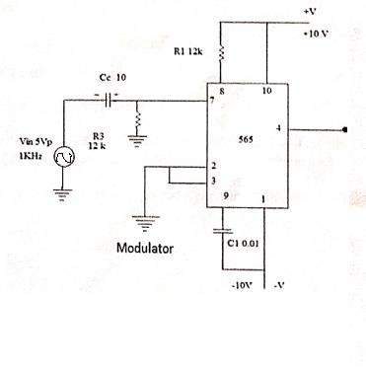

DESIGN
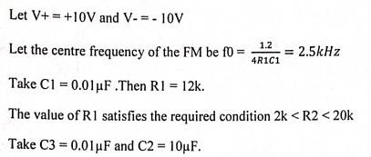

- FM Demodulator
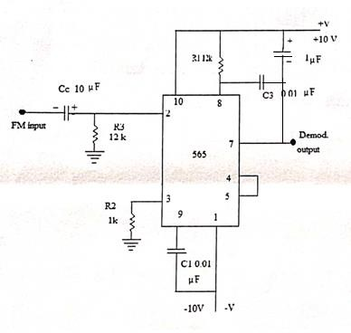

PROCEDURE
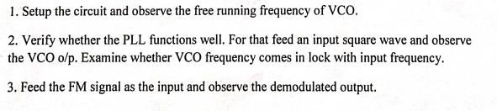

SAMPLE WAVEFORMS

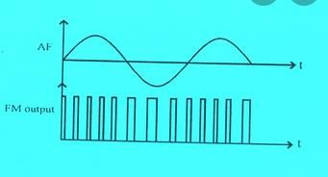

RESULT

EXPERIMENT No. 2

GENERATION AND DETECTION OF DELTA MODULATED SIGNALS

AIM

To design and set up delta modulator and demodulator circuit and obtain the output waveforms

COMPONENTS AND EQUIPMENTS USED
Op-amp, LM 311 IC, 7474 IC, resistors, capacitors, signal generator, bread board, power supplies and CRO

THEORY
Delta Modulation is a different PCM scheme in which the difference in signal is encoded into a single bit. This signal bit is transmitted per sample to indicate whether the signal is larger or smaller than the previous sample. Circuit for DM is shown in figure. The modulating signal m(t) and its quantized approximation m’(t) are applied to the comparator. Comparator provides a high level output when m(t)>m’(t) and it provides low level output when m(t)<m’(t).
The LM 311 chip is used in the circuit as the comparator. The output of the comparator is fed to a sample and hold circuit made by D flip flop. The clock frequency to flip-flop is selected at the sampling rate. Pulses at the output of D flip flop are made bipolar by an op-amp comparator. Bipolar pulses are converted to analog signal before feeding to the comparator using a RC low pass filter.

PROCEDURE

  - Set up the circuit after verifying the conditions of the components.
  - Feed a unipolar 5V,200Hz sine wave to the input using offset knob of function generator .Set the frequency at 2KHz.
  - Observe the DM output and Vo simultaneously on the CRO screen.
  - Set up the demodulator circuit
  - Verify the demodulated output with the message

CIRCUIT DIAGRAM
- Modulator
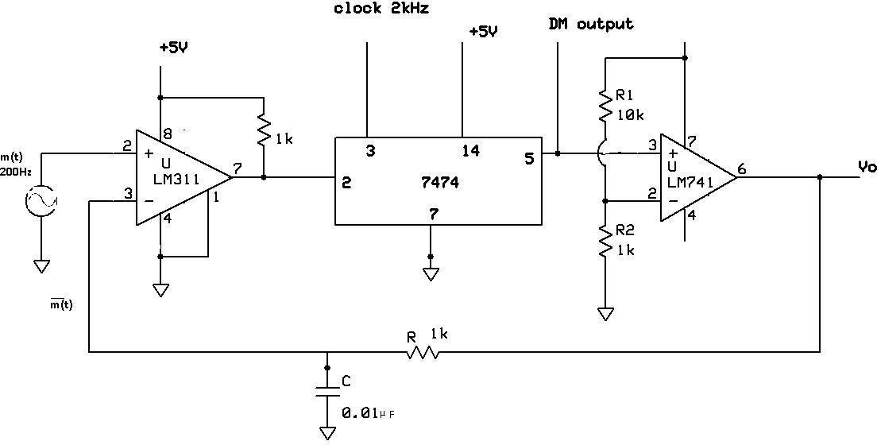

DESIGN
Let the input signal amplitude be5V and frequency be 200Hz .That is m(t) =5sin400πt Maximum slope of m(t) =2πfA = 2π2000*5 = 20000 π
To avoid slope over load error, VCC/RC> Em Wm
Selecting VCC=15VandC =0.01µF. we get R<228k.Take R =100k

Take R2 =1k.then R1 =10k

MODULATOR OUTPUT WAVEFORMS

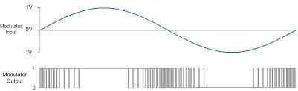

- Demodulator

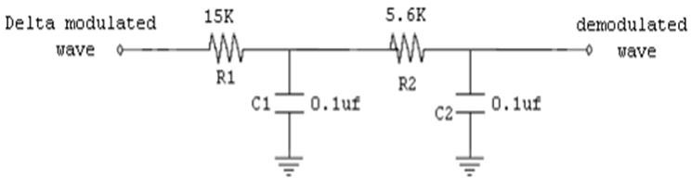

DESIGN
In demodulator, Low pass filter: fm < 1/2πR2C2
Take C2 = 0.1μF, then we get R2 = 5.6 k
SAMPLE WAVEFORM
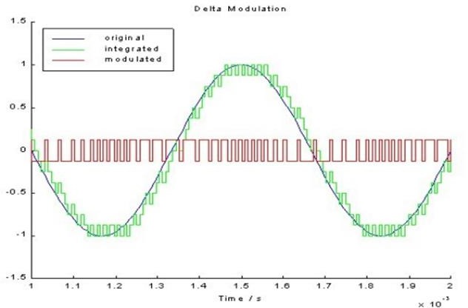

RESULT

EXPERIMENT NO. 3

PERFORMANCE OF WAVEFORM CODING USING PCM

AIM

value.

The performance measure of PCM using MATLAB.

- Generate a sinusoidal waveform with a DC offset so that it takes only positive amplitude

- Sample and quantize the signal using an uniform quantizer with number of representation

levels L. Vary L. Represent each value using decimal to binary encoder.
- Compute the signal-to-noise ratio in dB.
- Plot the SNR versus number of bits per symbol. Observe that the SNR increases linearly.

THEORY
Modulation is the process of varying one or more parameters of a carrier signal in accordance with the instantaneous values of the message signal. The message signal is the signal which is being transmitted or communication and the carrier signal is a high frequency signal which has no data but is used for long distance transmission.
There are many modulation techniques, which are classified according to the type of modulation employed. Of them all, the digital modulation technique used is Pulse Code Modulation PCM. A signal is pulse code modulated to convert its analog information into a binary sequence ,i.e., 1s and 0s. The output of a PCM will resemble a binary sequence. The following figure shows an example of PCM output with respect to instantaneous values of a given sine wave.
Instead of a pulse train, PCM produces a series of numbers or digits, and hence this process is
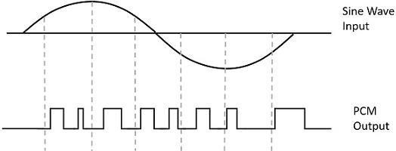
called as digital. Each one of these digits, though in binary code, represent the approximate amplitude of the signal sample at that instant.

In Pulse Code Modulation, the message signal is represented by a sequence of coded pulses. This message signal is achieved by representing the signal in discrete form in both time and amplitude.

Basic Elements of PCM
The transmitter section of a Pulse Code Modulator circuit consists of Sampling, Quantizing and Encoding, which are performed in the analog-to-digital converter section. The low pass filter prior to sampling prevents aliasing of the message signal.
The basic operations in the receiver section are regeneration of impaired signals, decoding, and reconstruction of the quantized pulse train. Following is the block diagram of PCM which represents the basic elements of both the transmitter and the receiver sections.
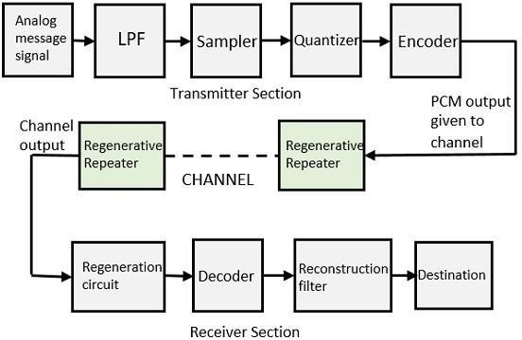

Block Diagram of PCM System.

Low Pass Filter :
This filter eliminates the high frequency components present in the input analog signal which is greater than the highest frequency of the message signal, to avoid aliasing of the message signal.

Sampler :
This is the technique which helps to collect the sample data at instantaneous values of message signal, so as to reconstruct the original signal. The sampling rate must be greater than twice the highest frequency component W of the message signal, in accordance with the sampling theorem.

Sampling is defined as, “The process of measuring the instantaneous values of continous time signal in a discrete form.” Sample is a piece of data taken from the whole data which is continuous in the time domain.
When a source generates an analog signal and if that has to be digitized, having1s and 0s i.e., High or Low, the signal has to be discretized in time. This discretization of analog signal is called as Sampling.

Quantizer :
Quantizing is a process of reducing the excessive bits and confining the data. The sampled output when given to Quantizer ,reduces the redundant bits and compresses the value.
The digitization of analog signals involves the rounding off the values which are approximately equal to the analog values. The method of sampling chooses a few points on the analog signal and then these points are joined to round off the value to a near stabilized value. Such a process is called as Quantization.
The analog-to-digital converters perform this type of function to create a series of digital values out of the given analog signal. The following figure represents an analog signal. This signal to get converted into digital, has to undergo sampling and quantizing.
The quantizing of an analog signal is done by discretizing the signal with a number of quantization levels. Quantization is representing the sampled values of the amplitude by a finite set of levels, which means converting a continuous-amplitude sample into a discrete-time signal.

Encoder :
The digitization of analog signal is done by the encoder. It designates each quantized level by a binary code. The sampling done here is the sample-and-hold process. These three sections LPF, Sampler, and Quantizer will act as an analog to digital converter. Encoding minimizes the bandwidth used.

Regenerative Repeater:
This section increases the signal strength. The output of the channel also has one regenerative repeater circuit, to compensate the signal loss and reconstruct the signal, and also to increase its strength.

Decoder
The decoder circuit decodes the pulse coded waveform to reproduce the original signal. This circuit acts as the demodulator.

Reconstruction Filter
After the digital-to-analog conversion is done by the regenerative circuit and the decoder, a low-pass filter is employed, called as there construction filter to get back the original signal. Hence, the Pulse Code Modulator circuit digitizes the given analog signal, codes it and samples it, and then transmits it in an analog form. This whole process is repeated in a reverse pattern to obtain the original signal.

MAT LAB CODE
clc;
clear all;
close all;
n=input('Enter for n-bit PCM system :'); %Encode book Bit Length
n1=input('Enter Sampling Frequency : '); %SamplingFrequency

%% Here we plot the Analog Signal and its Sampled form
%Vmax= 8;
t = 0:pi/n1:4*pi;%Construction of Signal. actually 2pi period, to get 2 cycles, we put 4pi
ActualSignal=sin(t)+3; %Actual input
subplot(3,1,1);
plot(ActualSignal);
title('AnalogSignal');
subplot(3,1,2); %Sampled Version
stem(ActualSignal);
grid on;
title('SampledSignal');

%% Now perform the Quantization Process
L=2^n;%NumberofQuantisationLevels
Vmin=round(min(ActualSignal));
Vmax=round(max(ActualSignal));
StepSize=(Vmax-Vmin)/L;%Difference between each quantisation level
QuantizationLevels=Vmin:StepSize:Vmax; %Quantisation Levels-for comparison
codebook=Vmin-(StepSize/2):StepSize:Vmax+(StepSize/2);%Quantisation Values As Final Output of quantization %
[ind,q]=quantiz(ActualSignal,QuantizationLevels,codebook);

% Quantization process
NonZeroInd=find(ind~=0);
ind(NonZeroInd)=ind(NonZeroInd)-1;
% MATLAB gives indexing from 1 to N. But we need indexing from 0,to convert it into binary code book

BelowVminInd = find(q == Vmin-(StepSize/2));
q(BelowVminInd)=Vmin+(StepSize/2);
%This is for correction, as signal values cannot go beyond Vmin
%But quantize may suggest it, since it return the Values lower than Actual signal values %

subplot(3,1,3);
stem(q);
grid on;
% Display the Quantize values
title('QuantizedSignal');

%% Having Quantised the values, we perform the Encoding Process
figure
TransmittedSig=de2bi(ind,'left-msb');
SerialCode=reshape(TransmittedSig.',1,size(TransmittedSig,1)*size(TransmittedSig,2));
subplot(2,1,1);
grid on;
stairs(SerialCode);
axis([0 40 -2 2]);
title('TransmittedSignal');

%% Now we perform the Demodulation Of PCM signal
ReceivedCode=reshape(SerialCode,n,length(SerialCode)/n);
%Again Convert the SerialCode into Frames of 1 Byte
index=bi2de(ReceivedCode','left-msb');
%BinarytoDecimalConversion
q=(StepSize*index);
%ConvertintoVoltageValues
q = q + (Vmin+(StepSize/2)); % Above step gives a DC shifted version of Actual signal
%Thus it is necessary to bring it to zero level
subplot(2,1,2);
grid on;
plot(q);
%Plot Demodulated signal
title('DemodulatedSignal');

%% Now we calculate SNR Of PCM signal
for Nvar=1:10
Lvar=2^Nvar;
StepSizevar=(Vmax-Vmin)/Lvar;%Difference between each quantisation level
QLevelvar=Vmin:StepSizevar:Vmax; %Quantisation Levels-for comparison
code=Vmin-(StepSizevar/2):StepSizevar:Vmax+(StepSizevar/2); %Quantisation Values As Final Output of quantization %
[ind,x]=quantiz(ActualSignal,QLevelvar,code);
a(Nvar)=snr(x,ActualSignal);
end
figure
Nvar=1:10;
plot(Nvar,a);

RESULT

SIMULATED WAVEFORM

.

EEXPERIMENT NO. 4

PULSE SHAPING AND MATCHED FILTERING
- To Generate a string of message bits.
- Use root raised cosine pulse p(t) as the shaping pulse, and generate the

corresponding baseband signal with a fixed bit duration Tb. You may use roll-off factor as α
= 0.4.
- Simulate transmission of baseband signal via an AWGN channel
- Apply matched filter with frequency response Pr(f ) = P ∗(f ) to the received signal.
- Sample the signal at mTb and compare it against the message sequence.

THEORY
In communication systems, data is transmitted as binary bits (ones and zeros). It is easier to implement a binary system using switches, where turning on a switch represents ‘1’ and turning it off represents ‘0’. Such simple binary systems essentially represent ones and zeros as rectangular pulses of finite duration (say τ seconds). A rectangular pulse of finite duration τ manifests itself as an infinitely extending sinc pulse in the frequency domain (see figure below). This implies that a rectangular pulse requires infinite bandwidth if it is not to be distorted during its transmission. Due to the dual nature of Fourier Transform, the following figure is valid if we alternate the frequency and time domain representations. That is, a symbol with finite bandwidth will extend infinitely in time. This implies that to send a single ‘1’ or ‘0’ or a series of them (for a multi-level signaling), you would need infinite time duration. This is absolutely impractical. In practical terms, signals will not extend infinitely forward and backward in time. But it will definitely be non-zero after the time duration τ. This implies that the residues of adjacent symbols/signals overlap with each other giving rise to Inter Symbol Interference (ISI). If the residual energy from the adjacent symbol is very strong, it becomes impossible to distinguish the present symbol and there is a possibility of it being misinterpreted altogether. To avoid or reduce this effect, “Pulse Shaping” techniques are used to make sure that the data carried by the symbols are not affected by the overlapping effect of adjacent symbols.

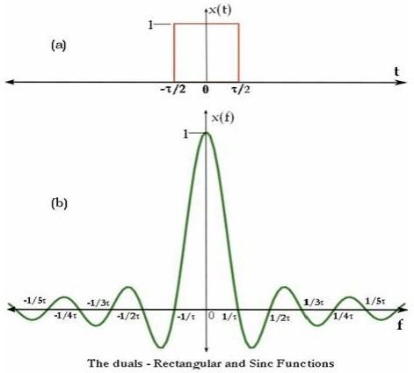

In a band-limited system, when we try to increase the data rate, it may lead to Inter Symbol Interference (ISI). There are two criteria that must be satisfied for a non-interference system when pulse shaping is employed. (1) The pulse shape exhibits a zero crossing at the sampling point of all pulse intervals (2) The shape of the pulses is such that the amplitude decays rapidly outside of the pulse interval. A rectangular pulse satisfies the first criterion (where it contains zero crossing – see figure above) but not the second criterion (the energy of the rectangular pulse does not decay rapidly outside the pulse interval and in fact it extends to infinite bandwidth). Pulse shapes filters like raised cosine filters, square root raised cosine filters and matched filters are employed to shape the transmitted pulses so that they will satisfy the above two criteria of providing an ISI free system. Refer [WebMichael] for a more intuitive treatment of Raised Cosine Filter. Raised Cosine Filters/Pulses: A Raised Cosine looks more like a modified sinc pulse in time domain and is given by the following function (This equation is apt for digital domain and Matlab simulation, it is obtained from its analog form by substituting “t” by n*TS

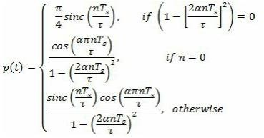

Here TS is the sampling period, n is the sample number, α is a parameter that governs the bandwidth occupied by the pulse and the rate at which the tails of the pulse decay. A value of α = 0 offers the narrowest bandwidth, but the slowest rate of decay in the time domain. When α = 1, the bandwidth is 1/τ, but the time domain tails decay rapidly. For more details on investigation of raised cosine characteristics and its implementation – refer links - [WebMichael], [WebKen], [WebComplex2Real] mentioned under the “External Links” section at the end of this book. The following Matlab program simulates a Raised Cosine Filter and plots its frequency response.

MATLAB CODE
clc;
clear all;
close all;
rolloff=0.4;
span=10;
sps=10;
M=4;
k=log2(M);
BP_data=2*randi([0 1],10,1)-1;
rectfilt=rcosdesign(rolloff,span,sps,'normal');
% rectfilt=rcosdesign(rolloff,span,sps,’sqrt’);
fvtool(rectfilt,'impulse')
UP_s=upfirdn(BP_data, rectfilt, sps,1);
plot(UP_s);
EbNo=100;
snr= EbNo +10*log10(k)-10*log10(sps);
rxSignal=awgn(UP_s,snr);
plot(rxSignal);
rxSignal= rxSignal+randn(size(rxSignal))*0.01;
plot(rxSignal);
rxfiltsignl= upfirdn(rxSignal, rectfilt, 1,sps);
rxfiltsignl=rxfiltsignl(span+1:end-span)
figure
stem(BP_data,'filled')
hold on;
plot(rxfiltsignl,'r');
legend('Transmitted data','Received signal')
figure
plot(rxSignal);
title('filtered signal through AWGN')

RESULT

SIMULATED WAVEFORM

EXPERIMENT NO. 5

AIM

EYE DIAGRAM
- To Generate a string of message bits.
- Use raised cosine pulse p(t) as the shaping pulse, and generate the corresponding

baseband signal with a fixed bit duration Tb. You may use roll-off factor as α = 0.4.
- Use various roll off factors and plot the eye diagram in each case for the received signal. Make a comparison study among them.

THEORY
In telecommunication, an eye pattern, also known as an eye diagram, is an oscilloscope display in which a digital signal from a receiver is repetitively sampled and applied to the vertical input, while the data rate is used to trigger the horizontal sweep. It is so called because, for several types of coding, the pattern looks like a series of eyes between a pair of rails. It is a tool for the evaluation of the combined effects of channel noise, dispersion and inter symbol interference on the performance of a baseband pulse-transmission system.
There are many measurements that can be obtained from an eye diagram:

Amplitude measurements

- Eye amplitude
- Eye crossing amplitude
- Eye crossing percentage
- Eye height
- Eye level
- Eye signal-to-noise ratio
- Quality factor
- Vertical eye opening

Time measurements

- Deterministic jitter
- Eye crossing time
- Eye delay
- Eye fall time
- Eye rise time

- Eye width
- Horizontal eye opening
- Peak-to-peak jitter
- Random jitter
- RMS jitter
- CRC jitter

Interpreting measurements

Eye-diagram feature | What it measures
Eye opening (height, peak to peak) | Additive noise in the signal
Eye overshoot/undershoot | distortion due to interruptions in the signal path
Eye width | Timing Synchronization & jitter effects
Eye closure | Inter symbol interference, additive noise

The raised-cosine filter is a filter frequently used for pulse-shaping in digital modulation due to its ability to minimise intersymbol interference (ISI). Its name stems from the fact that the non-zero portion of the frequency spectrum of its simplest form is a cosine function, 'raised' up to sit above the (horizontal) axis.

MAT LAB CODE

clc;
clear all;
close all;
rolloff_1=0.1;
rolloff_5=0.5;
span=10;
sps=8;
N=10;
BP_data=2*randi([0 1],N,1)-1;
rctfilt1=rcosdesign(rolloff_1,span,sps,'sqrt');
rctfilt5=rcosdesign(rolloff_5,span,sps,'sqrt');
UP_s1=upfirdn(BP_data, rctfilt1, sps,1);
UP_s5=upfirdn(BP_data, rctfilt5, sps,1);
figure
subplot(2,1,1)
plot(UP_s1);
subplot(2,1,2)
plot(UP_s5);
eyediagram((UP_s1),2*sps),title('alpha=0.1');
eyediagram((UP_s5),2*sps), title('alpha=0.5');

RESULT

EXPERIMENT No. 6

AIM

space.

ERROR PERFORMANCE OF BPSK
- To Generate a string of message bits.
- Encode using BPSK with energy per bit Eb and represent it using points in a signal-

- Simulate transmission of the BPSK modulated signal via an AWGN channel with

variance N0/2.
- Detect using an ML decoder and plot the probability of error as a function of SNR per bit Eb/N0.

THEORY

In Binary Phase Shift Keying (BPSK) only one sinusoid is taken as basis function modulation. Modulation is achieved by varying the phase of the basis function depending on the message bits.
A BPSK modulator can be implemented by coding the message bits using NRZ coding (1 represented by positive voltage and 0 represented by negative voltage) and multiplying the output by a reference oscillator running at carrier frequency ω.
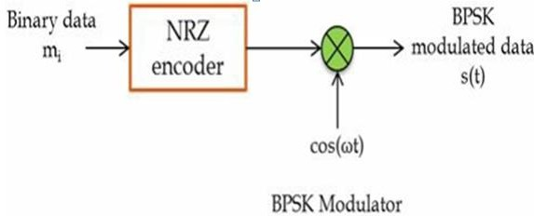

In the demodulator the received signal is multiplied by a reference frequency generator (assuming the PLL/Costas loop is present). The multiplied output is integrated over one bit period using an integrator. A threshold detector makes a decision on each integrated bit based on a threshold. Since an NRZ signaling format is used with equal amplitudes in positive and negative direction, the threshold for this case would be ’0′.

MATLAB CODE

clc;
clear all;
close all;
numBits=10^5;
bits=randi([0,1],numBits,1);
bpskSignal=2*bits-1;
%AWGN noise
EbNo_dB=0:10;
EbNo=10.^( EbNo_dB/10);

for i=1:length(EbNo_dB)
N0=1/ EbNo(i)
noise=sqrt(N0/2)*randn(size(bpskSignal))
receivedSignal= bpskSignal+noise;
receivedBits= receivedSignal>0;
error(i)=sum(bits~= receivedBits)
end
ber= error/ numBits;
theoryber=0.5*erfc(sqrt(EbNo));
semilogy(EbNo_dB,ber,'bo-');
hold on
semilogy(EbNo_dB, theoryber,'ro-');
hold off
grid on
legend('Simulated BER','Theorotical BER')
title('BPSK error performance');

SIMULATION RESULT

EXPERIMENT NO: 7

ERROR PERFORMANCE OF QPSK

AIM
- To generate a string of message bits.
- Encode using QPSK with energy per symbol Es and represent it using points in a signal- space. Simulate transmission of the QPSK modulated signal via an AWGN channel with variance N0/2 in 3.both I-channel and Q-channel.
4.Detect using an ML decoder and plot the probability of error as a function of SNR per bit Eb/N0 where Es = 2Eb.

THEORY
QPSK Modulation: In Quadrature Phase Shift Keying (QPSK) two sinusoids (sin and cos functions) are taken as basis functions for modulation. Modulation is achieved by varying the phase of the basis functions depending on the message symbols. In QPSK, modulation is symbol based, where one symbol contains 2 bits. The following equation outlines QPSK modulation technique. This gives four possible phases: π/4, 3π/4, 5π/4, 7π/4. The constellation diagram of QPSK will show the constellation points lying on both x and y axes. This means that the QPSK modulated signal will have an in-phase component (I) and also a quadrature component (Q). A QPSK modulator can be implemented as follows. A de- multiplexer (or serial to parallel converter) is used to separate odd and even bits from the generated information bits. Each of the odd bits (quadrature arm) and even bits (in-phase arm) are converted to NRZ format in a parallel manner. The signal on the in-phase arm is multiplied by cosine component and the signal on the quadrature arm is multiplied by sine component. SK modulated signal is obtained by adding the signal from both inphase and quadrature arm.

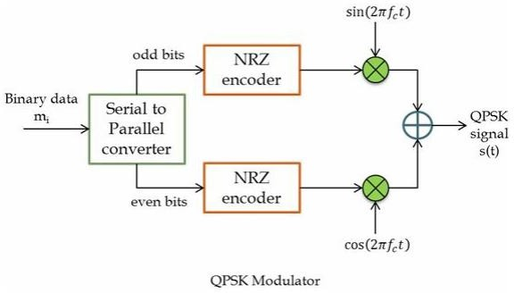
For QPSK demodulator, a coherent demodulator is taken as an example. In coherent detection technique, the knowledge of the carrier frequency and phase must be known to the receiver. This can be achieved by using a PLL (phase lock loop) at the receiver. A PLL essentially locks to the incoming carrier frequency and tracks the variations in frequency and phase. For the following simulation, a PLL is not used but instead we simply assume that the receiver is in perfect synchronization. For demonstration purposes we simply assume that the carrier phase recovery is done and simply use the generated reference frequencies at the receiver (cos(2πfC t)and (sin(2πfC t)).
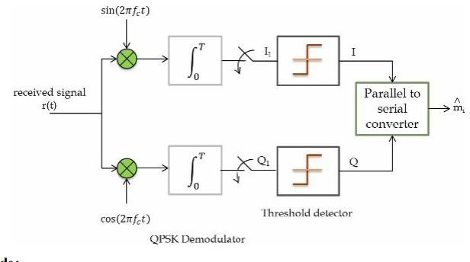

MATLAB CODE
% Demonstration of Eb/N0 Vs BER for QPSK modulation scheme

clc;
clear all;
close all;

numBits = 10^5; % Total number of bits (should be even for QPSK)
bits = randi([0,1], numBits, 1);

% Group bits into pairs for QPSK
bitPairs = reshape(bits, 2, []).';

% QPSK Mapping (Gray coding)
% 00 -> 1 + j
% 01 -> -1 + j
% 11 -> -1 - j
% 10 -> 1 - j

qpskSignal = (1-2*bitPairs(:,1)) + 1j*(1-2*bitPairs(:,2));
qpskSignal = qpskSignal / sqrt(2); % Normalize energy to 1

EbNo_dB = 0:10;
EbNo = 10.^(EbNo_dB/10);

for i = 1:length(EbNo_dB)

N0 = 1/(2*EbNo(i)); % Because QPSK carries 2 bits/symbol
noise = sqrt(N0/2) * (randn(size(qpskSignal)) + 1j*randn(size(qpskSignal)));

receivedSignal = qpskSignal + noise;

% Detection
detectedBits = zeros(size(bitPairs));
detectedBits(:,1) = real(receivedSignal) < 0;
detectedBits(:,2) = imag(receivedSignal) < 0;

detectedBits = reshape(detectedBits.', [], 1);

error(i) = sum(bits ~= detectedBits);
end

ber = error/numBits;

% Theoretical BER for QPSK (same as BPSK)
theoryber = 0.5 * erfc(sqrt(EbNo));

semilogy(EbNo_dB,ber,'bo-');
hold on;
semilogy(EbNo_dB, theoryber,'ro-');
hold off;
grid on;

legend('Simulated BER','Theoretical BER');
title('QPSK Error Performance');
xlabel('Eb/No (dB)');
ylabel('Bit Error Rate');

RESULT

SIMULATION OUTPUT

EXPERIMENT NO.8
FAMILIARIZATION WITH SOFTWARE DEFINED RADIO
(HARDWARE AND CONTROL SOFTWARE)

AIM:

1.Familiarize with an SDR hardware for reception and transmission of RF signal.
2. Familiarize how it can be interfaced with computer.
3. Familiarize with GNU Radio (or similar software’s like Simulink/ Lab-View) that can be used to process the signals received through the SDR hardware.
4. Familiarize available blocks in GNU Radio. Study how signals can be generated and spectrum (or power spectral density) of signals can be analyzed. Study how filtering can be performed.

KIT CONTENTS:

- Analog Devices Pluto-SDR active learning module
- Two antennas (824 MHz to ~894 MHz/ 1710 MHz to ~2170 MHz)
- One 15 cm SMA cable
- One USB cable
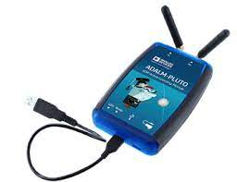

The ADALM-PLUTO Active Learning Module (Pluto SDR) is an easy to use tool available from Analog Devices Inc. (ADI) that can be used to introduce fundamentals of Software Defined Radio (SDR) or Radio Frequency (RF) or Communications as advanced topics in electrical engineering in a self or instructor lead setting. The PlutoSDR allows students to better understand the real-world RF around them, and is applicable for all students, at all levels, from all backgrounds. Early learning in a hands-on manner with the PlutoSDR will ensure a solid foundation for students to build on, as they pursue science, technology, or engineering degrees.
The PlutoSDR Active Learning Module is a tool that closes the relationship between theory and practical radio frequency activities of the user. It provides a personal portable lab that, when used with a host, can augment the learning that takes place in the classroom. A variety of software packages such as MATLAB or Simulink provide an innovative graphical user interface (GUI), allowing intuitive usage and minimizing the learning curve, enabling students to learn faster, work smarter, and explore more!
The ADALM-PLUTO Active Learning Module is a learning tool for everyone.
Based on the AD9363, it offers one receive channel and one transmit channel which can be operated in full duplex, capable of generating or measuring RF analog signals from 325 to 3800 MHz, at up to 61.44 Mega Samples per Second (MSPS) with a 20 MHz bandwidth. The Pluto SDR is completely self-contained, fits nicely in a shirt pocket or backpack, and is entirely USB powered with the default firmware. With support for OS X™, Windows™, and Linux™, it allows exploration and understanding of RF systems no matter where the user is or when.
Features
- Portable self-contained RF learning module
- Cost-effective experimentation platform
- RF coverage from 325 MHz to 3.8 GHz
- Flexible rate, 12-bit ADC and DAC
- One transmitter and one receiver (female SMA, 50 Ω)
- Half or full duplex X MATLAB, Simulink support
- GNU Radio sink and source blocks
- Libiio, a C, C++, C#, and Python API
- USB 2.0 interface
- Plastic enclosure
- USB powered
- Up to 20 MHz of instantaneous bandwidth (complex I/Q)

Connection:
Note: Disconnect ADALM Pluto while installing and software or drivers related to Analog devices.
- Connect ADALM-Pluto via USB to system installed with GNU radio Companion and ADALM Drivers connect Transmitter and receiver antenna
- Open GNU radio Companion
- Windows search in start (click on GNU radio Companion or GRC)
- Linux Type GNU radio-companion in Terminal
- Build flow graph or use existing examples to open project
- Build and run project
- Use GUI visualize to see frequency/Time/waterfall/constellation plots.
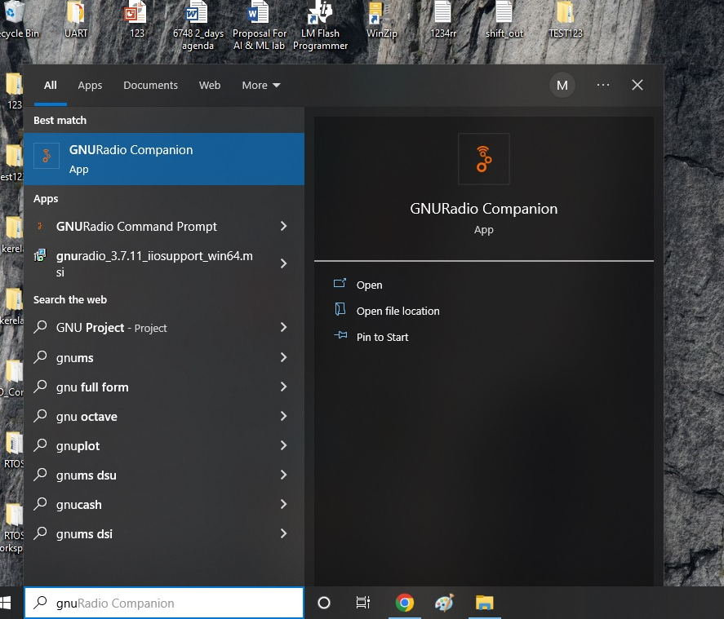

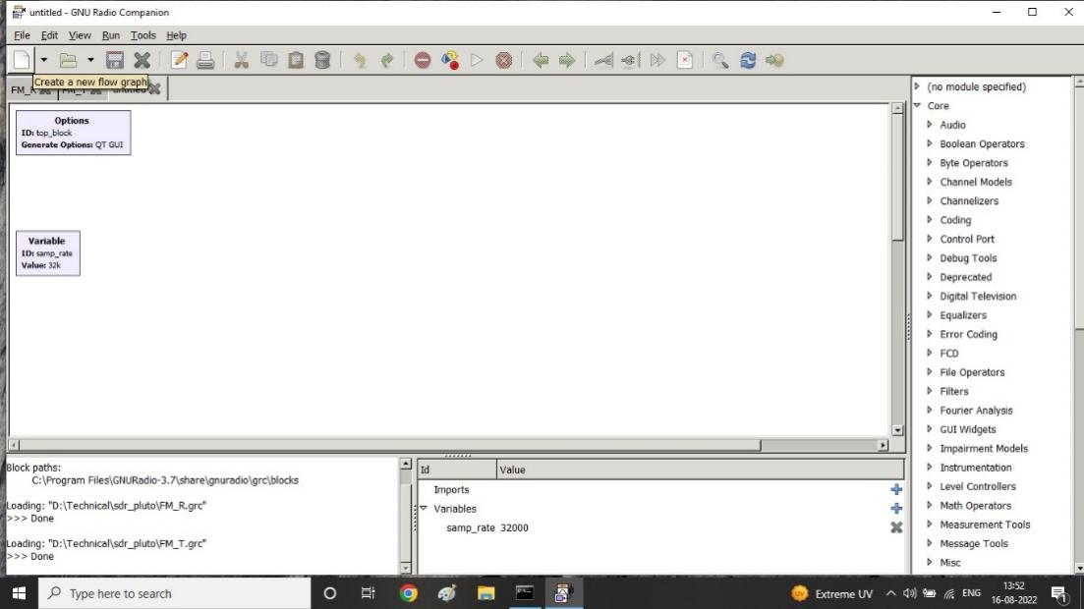

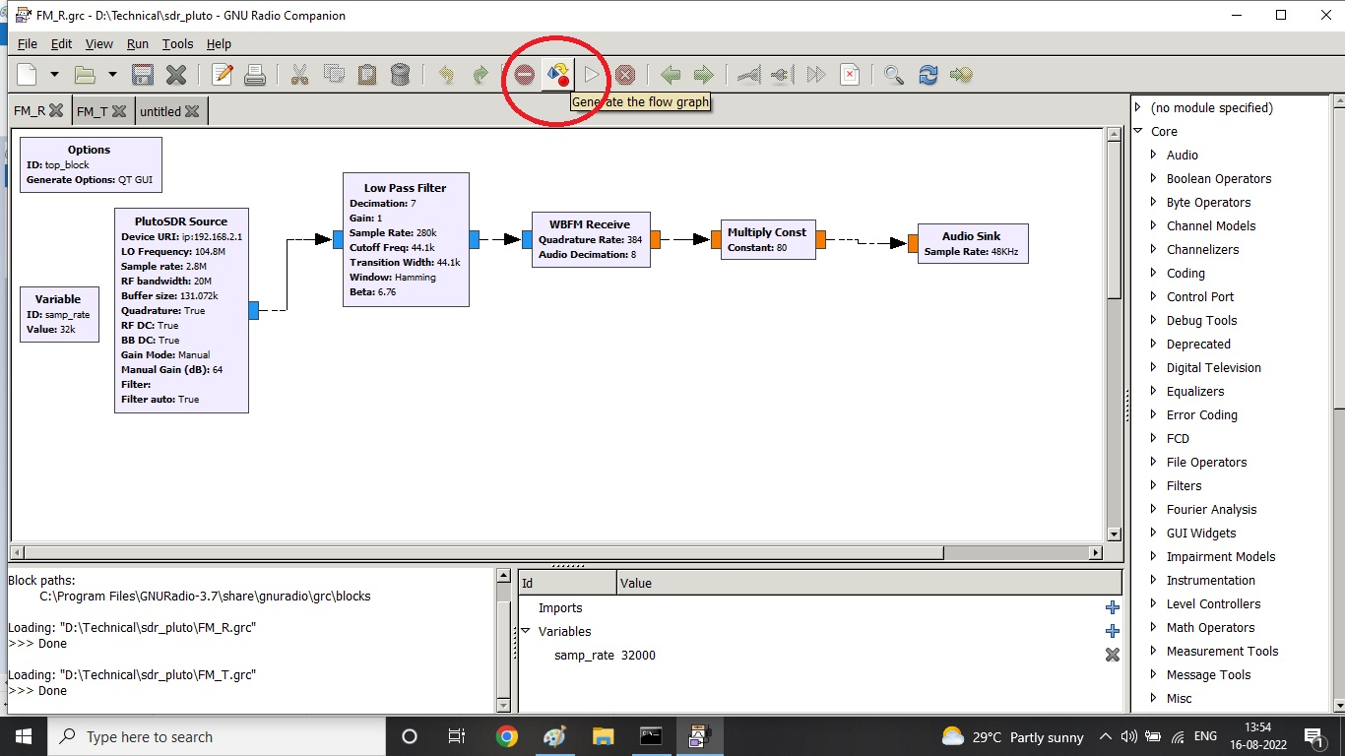
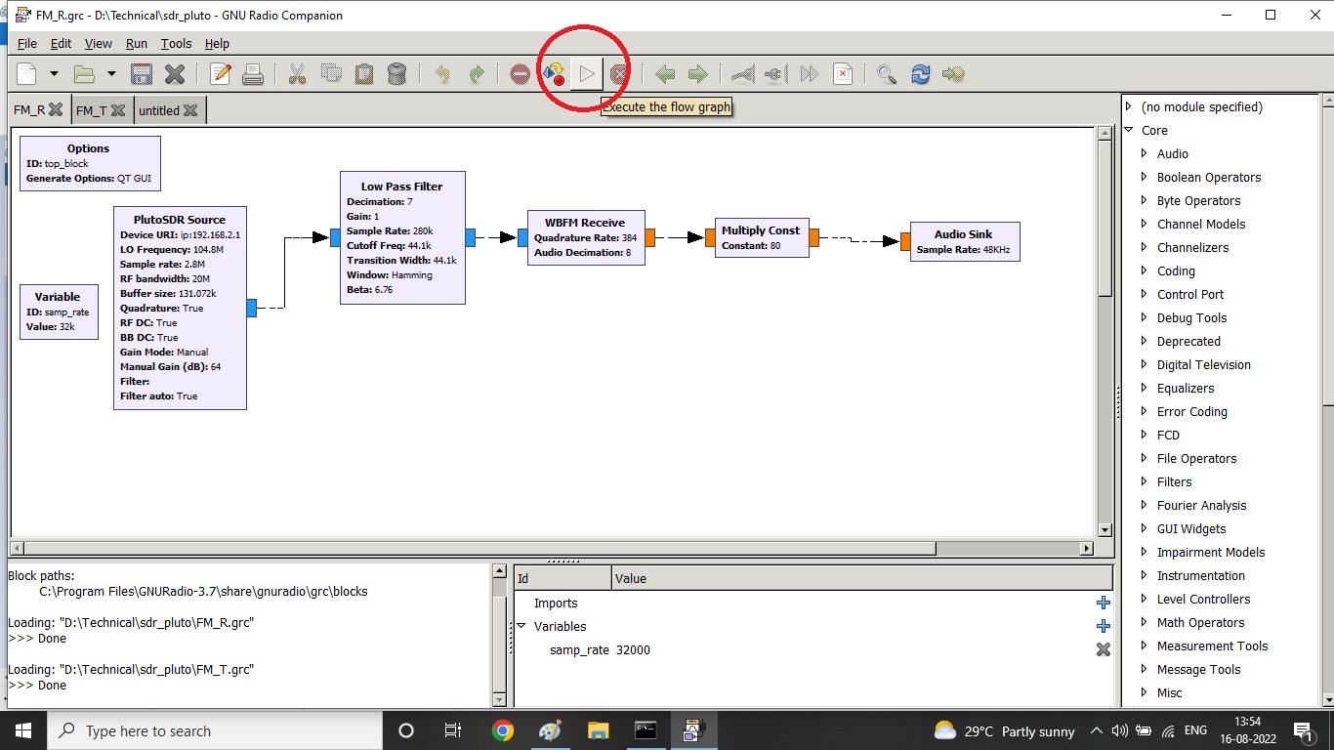
RESULT:

EXPERIMENT NO. 9
FM RECEIVER
AIM:

1. Receive digitized FM signal (for the clearest channel in the lab) using the SDR board.
2. Set up an LPF and FM receiver using GNU Radio.
3. Use appropriate sink in GNU Radio to display the spectrum of signal.
4. Resample the voice to make it suitable for playing on computer speaker.
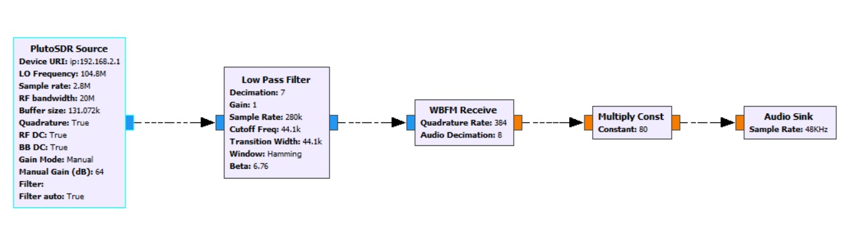
PLUTO SDR SINK
IIO context URI
IP address of the unit, e.g. "ip:192.168.2.1" (without the quotes)

LO Frequency
Selects the TX local oscillator frequency.

Sample Rate
Sample rate in samples per second, this will define how much bandwidth your SDR transmits (the RF bandwidth parameter below just defines the filter). limits: >= 520833 and <= 61440000. A FIR filter needs to be loaded or set to auto for values below 2.083 MSPS.

RF Bandwidth
Configures TX analog filters: TX BB LPF and TX Secondary LPF. limits: >= 200000 and <= 52000000

Buffer size
Size of the internal buffer in samples. The IIO blocks will only input/output one buffer of samples at a time. To get the highest continuous sample rate, try using a number in the millions.

LOW PASS FILTER:
FIR Type (R)
Specify whether input/output is real or complex

Decimation
Decimation rate of filter, must be an integer, and cannot change in realtime.

Gain (R)
Scaling factor applied to output.

Sample Rate (R)
Input sample rate.

Cutoff Freq (R)
Cutoff frequency in Hz

Transition Width (R)
Transition width between stop-band and pass-band in Hz

Window (R)
Type of window to use

Beta (R)
The beta paramater only applies to the Kaiser window.

WIDE BAND FREQUENCY MODULATION RECEIVER (WBFM)
Channel Rate
Input sample rate of complex baseband input. (float)

Audio Decimation
How much to decimate Channel Rate to get to audio. (integer)

Deviation
FM modulation deviation. Standard broadcast FM uses 75kHz

Audio Pass
Low pass filter roll-off frequency

Audio Stop
Low pass filter cut-off frequency

Gain
Audio gain

Tau
Pre-emphasis time constant (float) - typically 75e-6

MULTIPLY CONST

Constant (R)
Scalar or vector constant. If the input is a vector, this parameter must be a vector of the same size. To multiply all the input items by the same value, use Fast Multiply Const.
AUDIO SINK
Allows a signal to be played through your speakers or other audio device

Sample Rate

To set the Audio sampling rate, click the drop-down menu to see popular rates. Note: not all sampling rates will be supported by your hardware. For typical applications, this should be set to 48kHz.

RESULT:

EXPERIMENT NO. 10
FM TRANSMITTER
AIM:

1. Use a wave file source.
2. Set up an FM transmitter using GNU Radio.
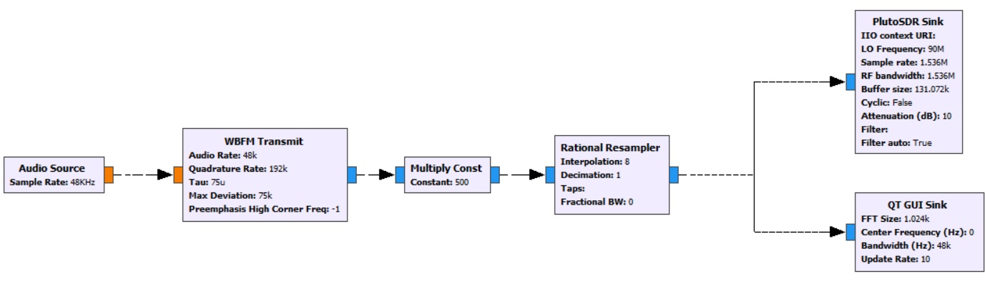
3. Resample the voice source and transmit using the SDR.

AUDIO SOURCE
Acts as a microphone input. See Audio Sink for a block that outputs to an audio device such as a speaker.

Sample Rate
To set the Audio sampling rate, click the drop-down menu to see popular rates. Note: not all sampling rates will be supported by your hardware. For typical applications, this should be set to 48kHz.
WIDE BAND FM TRANSMIT (WBFM)
Audio Rate
Sample rate of audio stream, >= 16k (integer)

Quadrature Rate
Sample rate of output stream (integer). Must be an integer multiple of audio_rate.

Tau
Pre emphasis time constant (default 75e-6) (float)

Max Deviation
Maximum deviation in Hz (default 75e3) (float)

Pre emphasis High Corner Freq
High frequency at which to flatten pre emphasis; < 0 means default of 0.925*quad rate/2.0 (float)

MULTIPLY CONST

Constant (R)
Scalar or vector constant. If the input is a vector, this parameter must be a vector of the same size. To multiply all the input items by the same value, use Fast_Multiply_Const.

RATIONAL RESAMPLER
Interpolation
Interpolation factor (integer > 0)

Decimation
Decimation factor (integer > 0)

Taps (R)
Optional filter coefficients (sequence)

Fractional BW
Fractional bandwidth in (0, 0.5), measured at final freq (use 0.4) (float). In GNU Radio 3.8, the default value is 0, which should either be changed to a value 'between' 0 and 0.5; or just removed. Removing the value of fractional bandwidth will cause the block to use the default value of 0.4.

PLUTO SDR SINK

IIO context URI
IP address of the unit, e.g. "ip:192.168.2.1" (without the quotes)

LO Frequency
Selects the TX local oscillator frequency.

Sample Rate
Sample rate in samples per second, this will define how much bandwidth your SDR transmits (the RF bandwidth parameter below just defines the filter). limits: >= 520833 and <= 61440000. A FIR filter needs to be loaded or set to auto for values below 2.083 MSPS.

RF Bandwidth
Configures TX analog filters: TX BB LPF and TX Secondary LPF. limits: >= 200000 and <= 52000000

Buffer size
Size of the internal buffer in samples. The IIO blocks will only input/output one buffer of samples at a time. To get the highest continuous sample rate, try using a number in the millions.

Cyclic
Set to true if the cyclic mode is desired. In this case, the first buffer of samples will be repeated on the Pluto SDR until the program is stopped. The Pluto SDR IIO block will report its processing as complete: the blocks connected to the Pluto SDR IIO block won't execute anymore, but the rest of the flow graph will.

Attenuation TX1 (dB)
Controls attenuation for TX1. The range is from 0 to 89.75 dB in 0.25dB steps. Note: Maximum output occurs at 0 attenuation.

Filter
Allows a FIR filter configuration to be loaded from a file.

Filter Auto
When enabled loads a default filter and thereby enables lower sampling / baseband rates.

RESULT:

